There are three ways to electronically register your proxy vote prior to the AGM

1. Via the iProxy platform
2. Via USSD
3. Via WhatsApp

You do not have to register a proxy and can attend the virtual meeting on the day to cast your vote.

# Voting via the online platform

To access the iProxy platform: <https://sabzenzelekabili.vagm.africa>

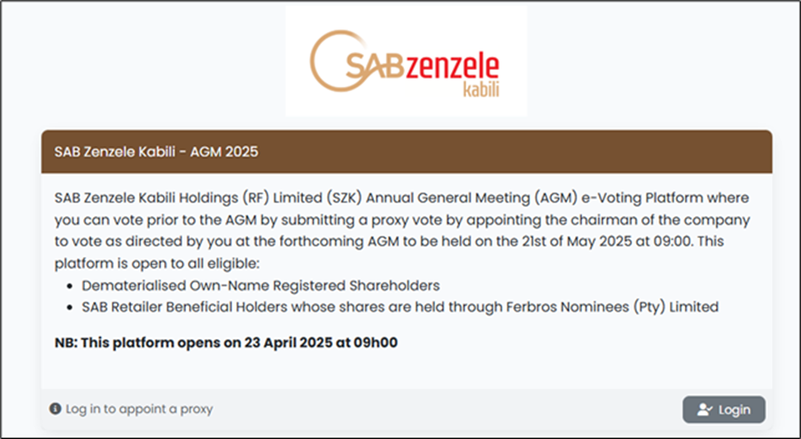



The login credentials are:

• Own-Name Registered Shareholders: Use your Shareholder Reference Number as your Username and your SA ID number as your Password

• SAB Retailer Beneficial Holders whose shares are held through Ferbros Nominees (Pty) Limited: Use your Participant Code (inclusive of the three leading zeros) as your Username and your SA ID number as your Password.

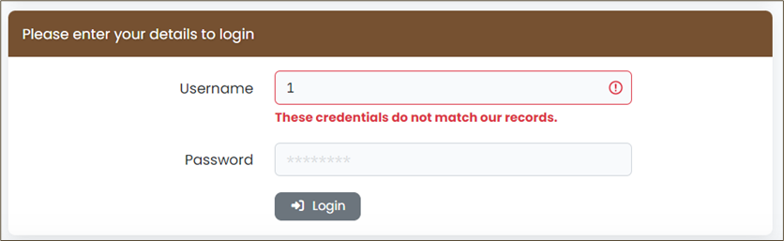

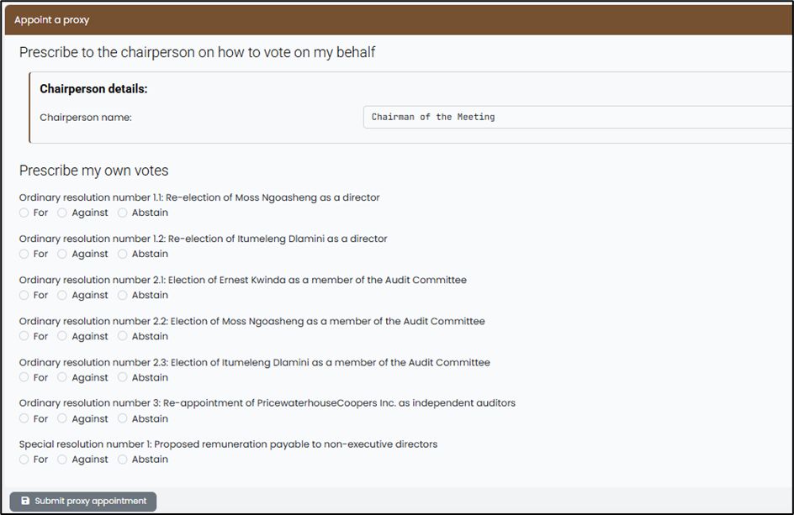

Revoking your proxy vote

Up to the closing date and time to lodge a proxy vote (09h00 on 19 May 2025), you can revoke your proxy appointment by clicking the red Revoke my proxy appointment button. This will prompt a pop-up to open that requires you to confirm that you wish to revoke your proxy vote (see below).

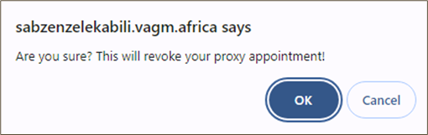

# Using the USSD Platform to vote your proxy vote Dial **\*134*520#**

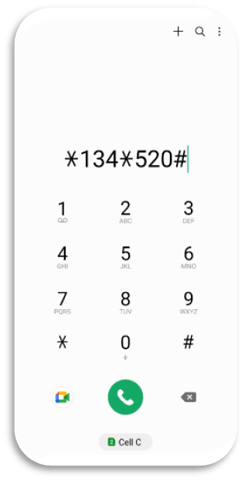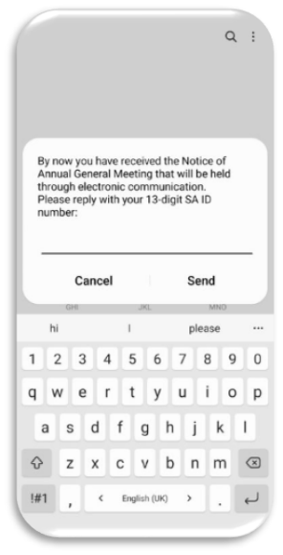

Then follow the on screen instructions

1. Using the WhatsApp Platform to vote your proxy vote Dial 27 87 240 6765

The WhatsApp Platform may be accessed by messaging number 27 87 240 6765 in your WhatsApp or by clicking on the below QR Code



Important points to note:

* The same screen messages are used on both the USSD and WhatsApp platforms.
* The platform links your mobile to your SA ID Number, and as a result, when you dial in again, any incomplete voting journey can be continued at the place where you left off.
* The platform is designed to review the SA ID inputted. If the number does not start with the YYYYMMDD format and is 13 digits in length, the platform will keep sending you the screen message “Invalid RSA ID Number, please try again”.
* The USSD and WhatsApp platform will close at the same time as the submission of proxies closes at 09h00 on 19 May 2025.

1. Attending and Voting on the day of the AGM – 21.05.2025

Logging onto the platform

Follow the same login process as detailed in point 2 on page 5 of this document.

If you have not cast a proxy vote prior to the AGM, you will login at the same URL to vote on the day of the AGM, which is <https://sabzenzelekabili.vagm.africa>.

Voting during the Virtual AGM

Click on the Attend and Vote Online Button. This action will open the voting page (see overleaf). This screen is into two sections showing the following features:

• Live Stream (this is where you will watch the webcast)

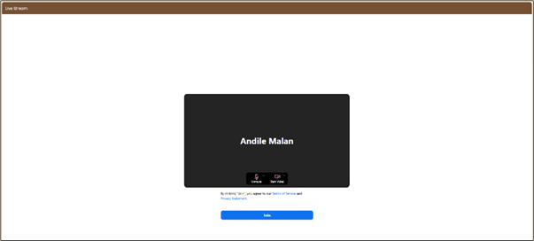

• My Votes (this is where you cast your votes if you have not already done so by proxy).

